

|  |  |
| --- | --- |
| ***Quick Calligraphy***    APTECH | WEBSITE DOCUMENTATION |

***Faculty***

**MISS KISHWAR JAHAN**

Figure 1

***GROUP MEMBER***

|  |  |  |
| --- | --- | --- |
| STD, NAME’S | ID’S | BATCH CODE |
| Mr. WASIF JUNAID ZAMAN | **1508350** | **202308E** |
| Mr. MUHAMMAD UMAIR KHAN | **1506093** | **202308E** |
| Mr. MOIZ KHALID | **1505866** | **202308E** |
| Mr. AHSAN | **1508265** | **202308E** |

***INDEX***

* **PROJECT SPECIFICATIONS 04**
* **PROJECT MEMBERS: 05**
* **DISTRIBUTION WORK: 06**
* **PROJECT SECTIONS: 06**
  + - * **HOME PAGE: 07**
      * **NAVIGATION AND SLIDER: 06**
      * **NAVIGATION AND SLIDER CODE: 08**
      * **CATLOGUE: 09**
      * **CATLOGUE CODE: 09**
      * **CATEGORIES: 10**
      * **CATEGORIES CODE: 20**
      * **OUR FEATURED COLLECTION CODE: 11**
      * **OUR FEATURED COLLECTION CODE: 11**
* **ABOUT US:** 
  + - * **QUICK CALLIGRAPHY: 12**
      * **ABOUR US QUICK CALLIGRAPHY CODE: 13**
      * **VIDEO: 13**
      * **VIDEO CODE: 14**
      * **OUR TEAM: 14**
      * **OUR TEAM CODE: 15**
      * **COUNTER: 15**
      * **COUNTER CODE: 16**
      * **FOOTER: 16**
      * **FOOTER CODE: 17**
* **CATEGORIES:** 
  + - * **CATEGORIES CARDS: 18**
      * **CATEGORIES CARDS: 19**
      * **CATEGORIES CARD MODAL: 20**
      * **CATEGORIES CARD MODAL CODE: 20**
* **CONTACT US:** 
  + - * **CONTACT US: 21**
      * **CONTACT US CODE: 21**
* **GALLERY:** 
  + - * **ANIMATE SLIDER: 22**
      * **ANIMATE SLIDER HTML CODE: 22**
      * **ANIMATE SLIDER CSS CODE: 23**
      * **CARDS: 23**
      * **CARDS CODE: 24**
      * **CARDS MODAL: 25**
      * **CARDS MODAL CODE: 25**

***PROJECT***

***SPECIFICATIONS***

1. The home page must describe the keywords or highlight the calligraphy designs with all navigation links defined.
2. The site should provide the brief information about calligraphy as from where it originated etc.
3. There should be various categories (forms and styles) like easy for kids, complex for elders and so on
4. There should also be categories of designs as Arabic, Indic, Greek etc(more categories can be added)
5. Contact us page: contact us details with location should be displayed using GeoLocation API (eg. GoogleMaps).
6. About Us
7. Feedback form
8. Gallery section should be added.
9. Color combination must be uniform throughout the project.
10. Navigation must be smooth.

***PROJECT MEMBERS***

|  |  |  |
| --- | --- | --- |
| STD, NAME’S | ID’S | BATCH CODE |
| Mr. WASIF JUNAID ZAMAN | **1508350** | **202308E** |
| Mr. MUHAMMAD UMAIR KHAN | **1506093** | **202308E** |
| Mr. MOIZ KHALID | **1505866** | **202308E** |
| Mr. AHSAN | **1508265** | **202308E** |

***DISTRIBUTION WORK***

|  |  |
| --- | --- |
| **name** | **work** |
| **Mr. WASIF JUNAID ZAMAN** | **HOME PAGE, CATEGORIES PAGE** |
| **Mr. MUHAMMAD UMAIR KHAN** | **CONTACT US, CONTENT SEARCHING** |
| **Mr. AHSAN** | **ABOUT US PAGE, GALLERY PAGE** |
| **Mr. MOIZ KHALID** | **DOCUMENTATON** |

***PROJECT SECTIONS***

**HOME PAGE:**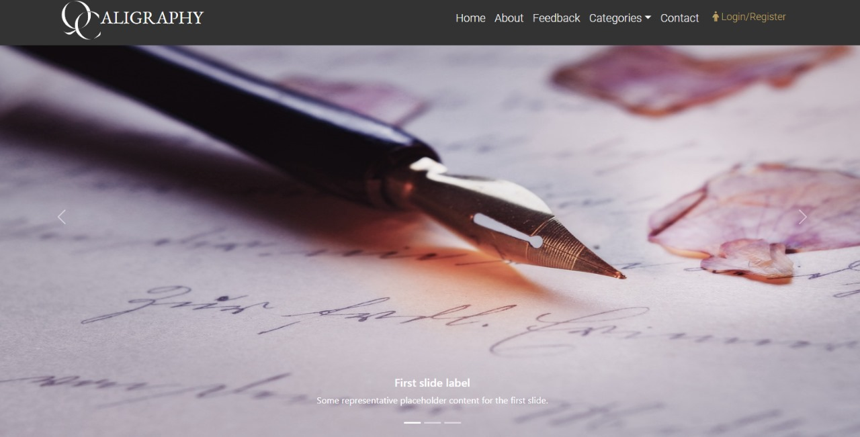

**INDEX NAVIGATION AND SLIDER:**

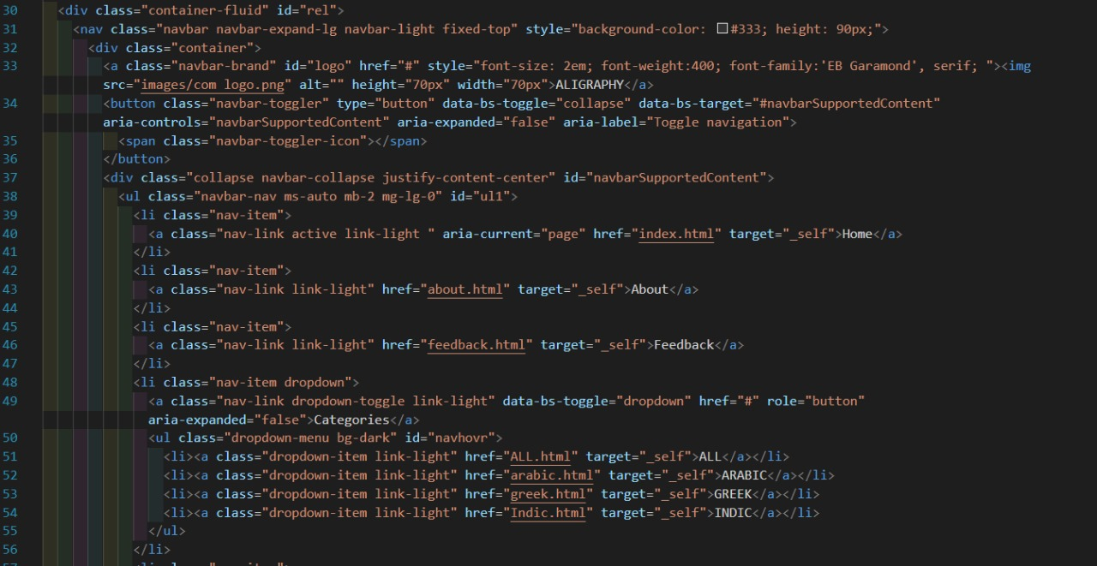

**INDEX NAVIGATION CODE:**

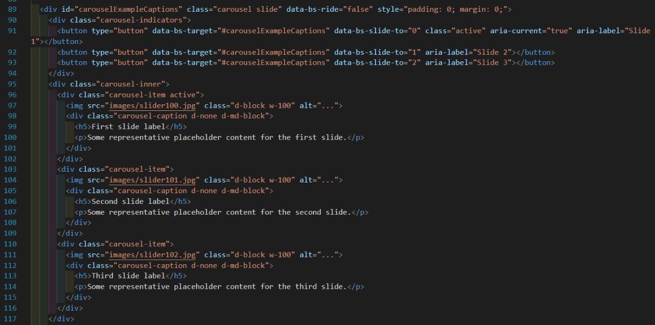

**INDEX SLIDER CODE:**

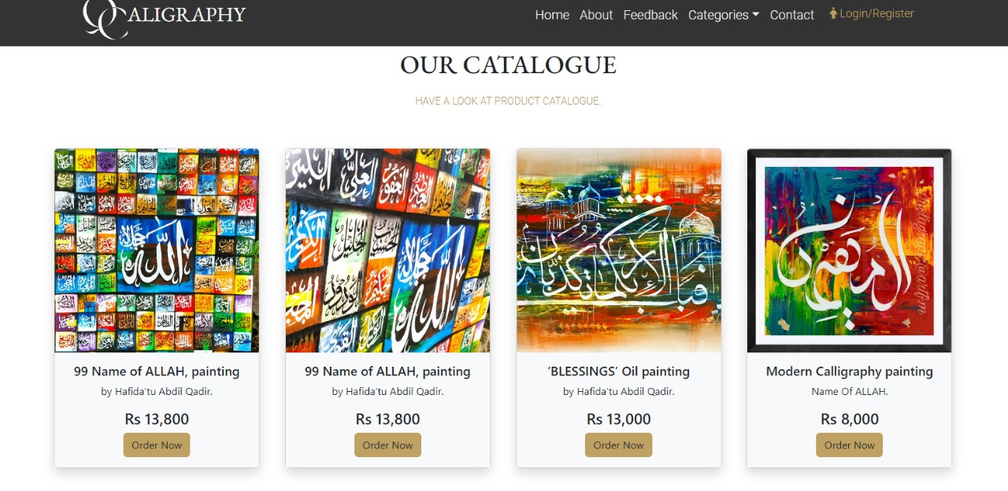***INDEX OUR CATLOGUE***

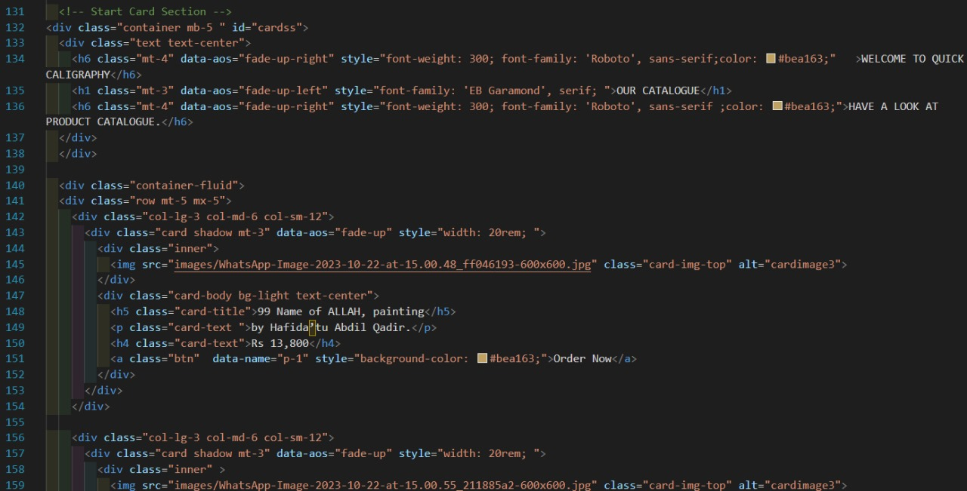 **INDEX OUR CATALOGUE:**

**INDEX OUR CATALOGUE CODE:**

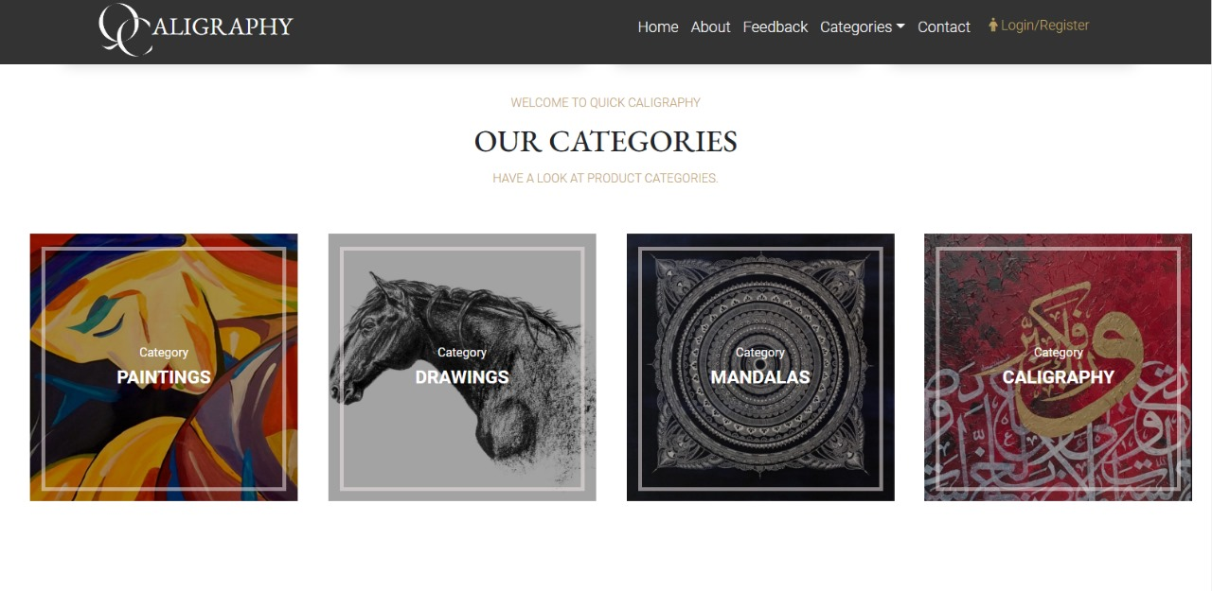***Our CATEGORIES***

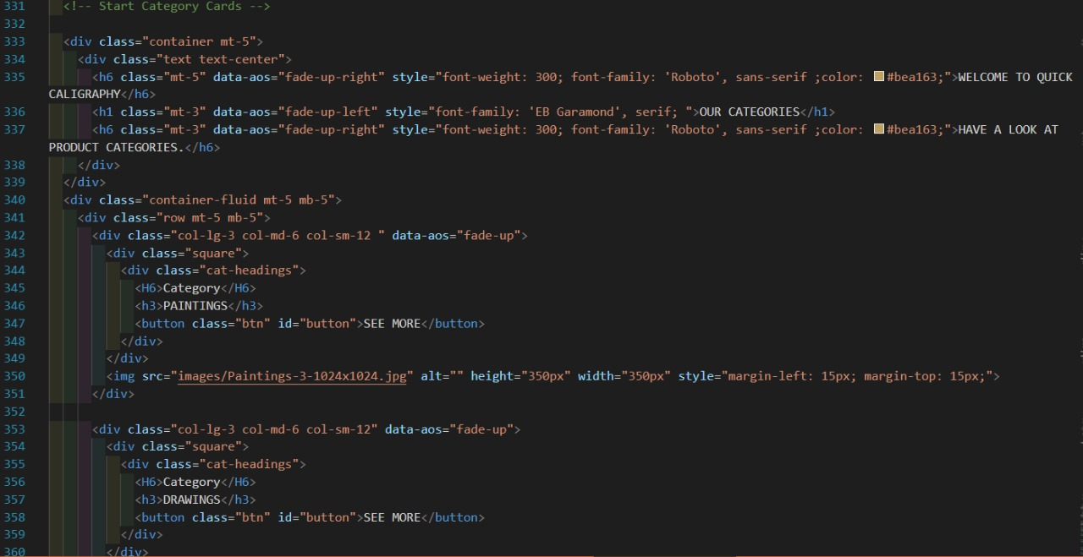 **INDEX OUR CATEGORIES:**

**INDEX OUR CATEGORIES CODE:**

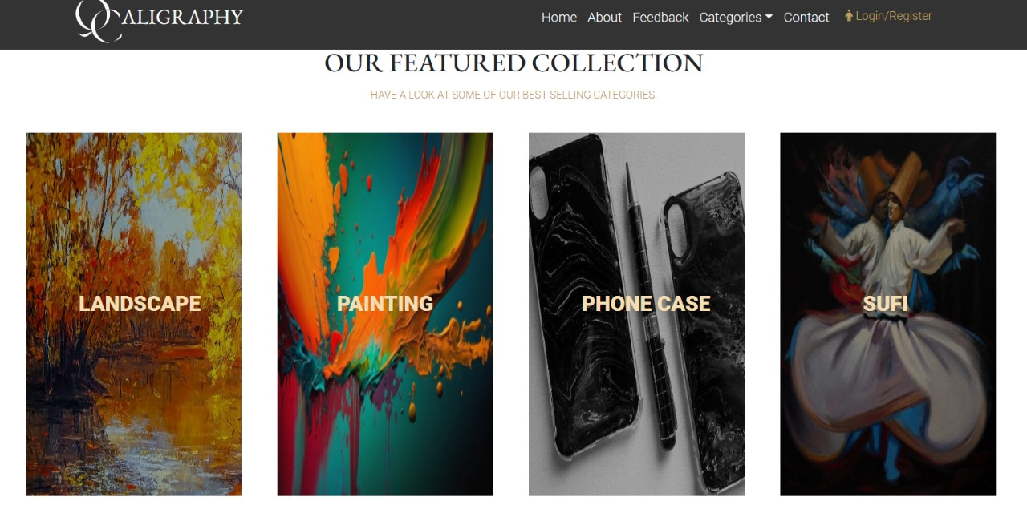

**INDEX OUR FEATURED COLLECTION:**

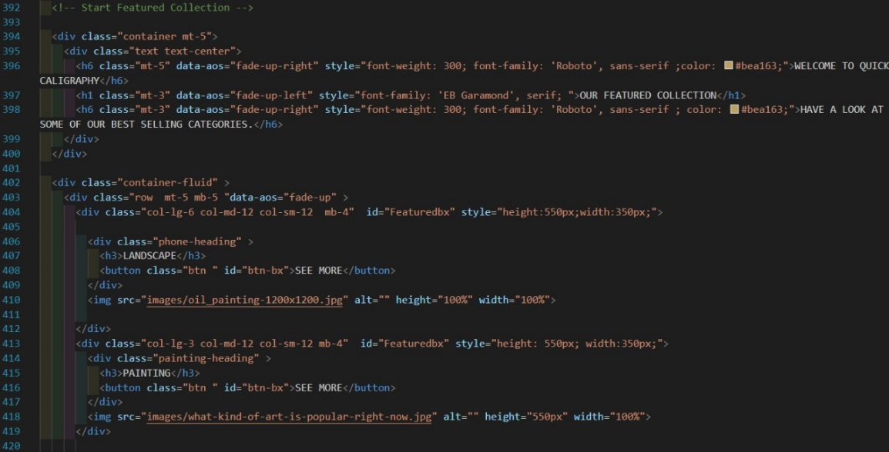

**INDEX OUR FEATURED COLLECTION CODE:**

***About us***

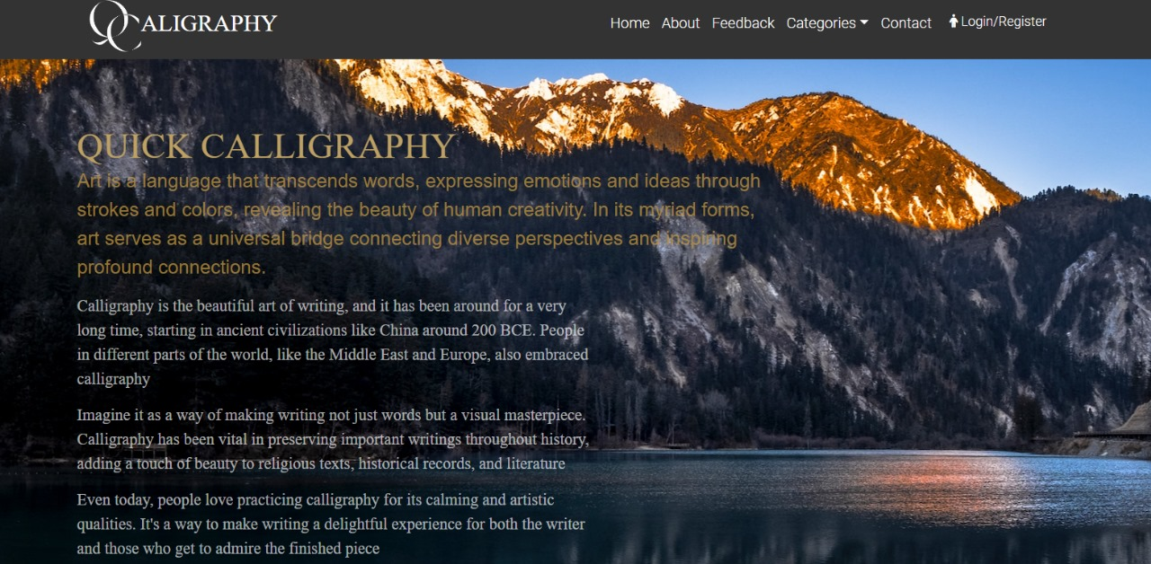

**QUICK CALLIGRAPHY ABOUT:**

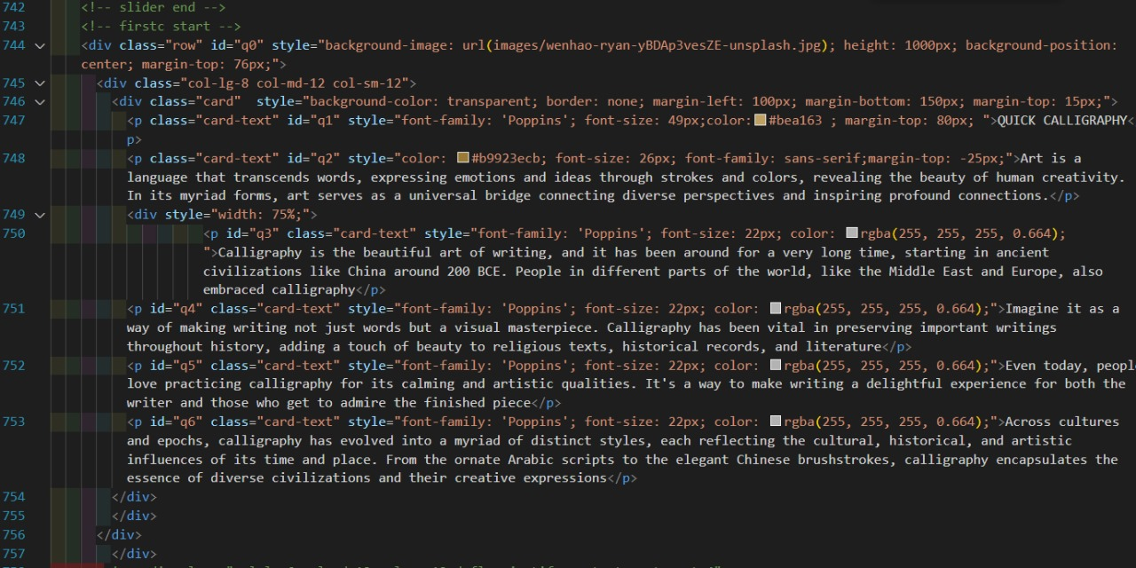

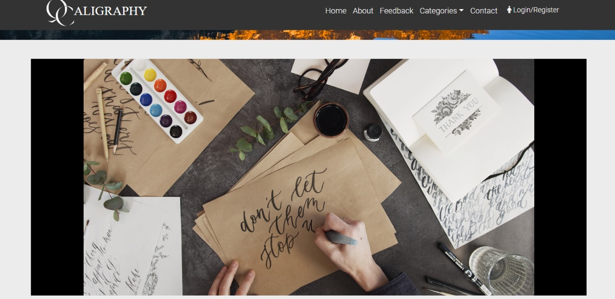**QUICK CALLIGRAPHY ABOUT CODE:**

**ABOUT US VIDEO:**

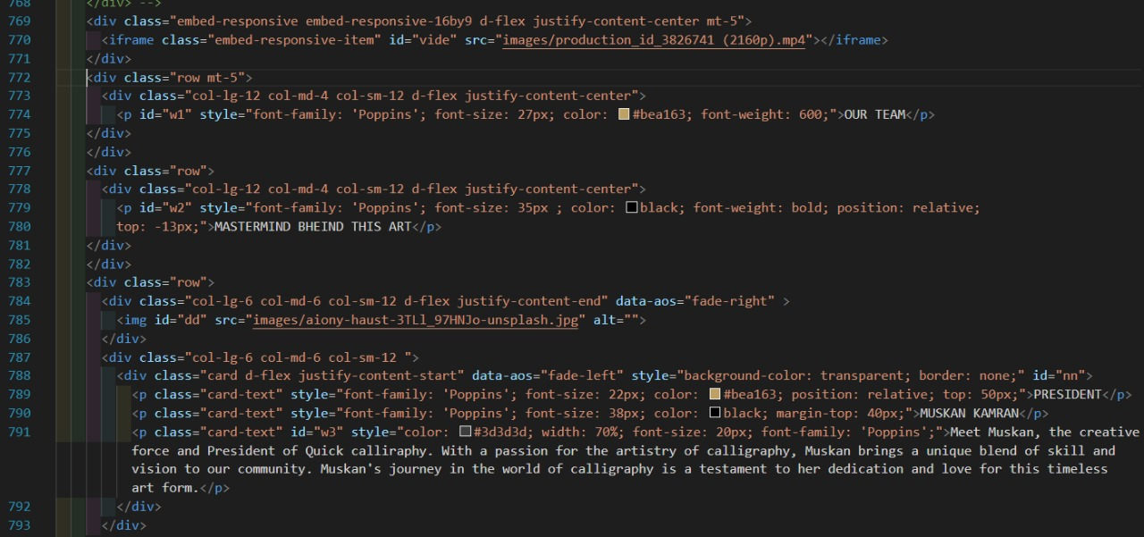

**ABOUT US VIDEO CODE:**

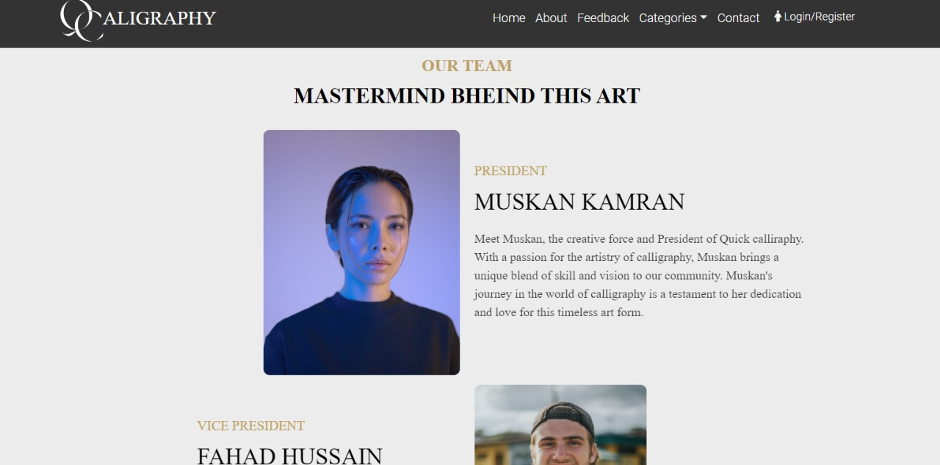

**OUR TEAM:**

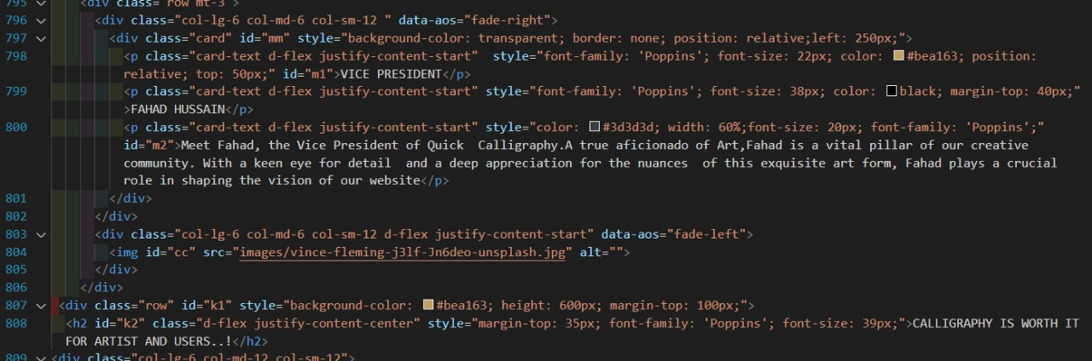

**OUR TEAM CODE:**

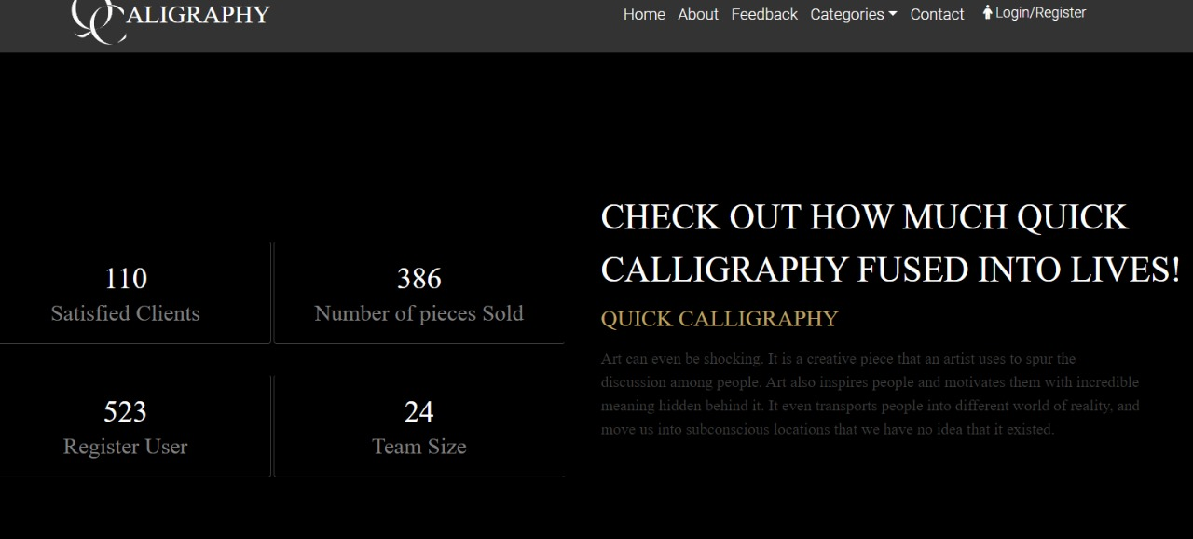

**ABOUTS US COUNTER:**

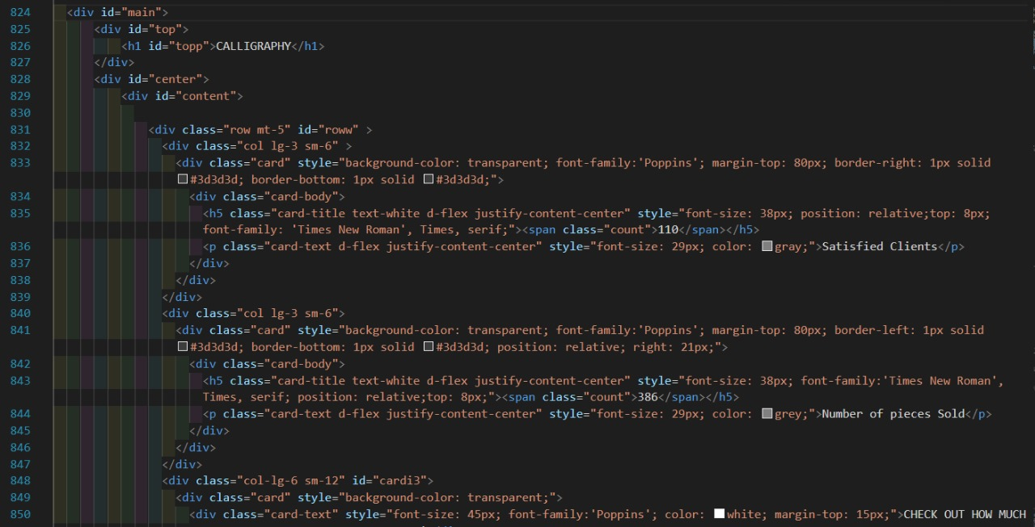**ABOUT US COUNTER CODE:**

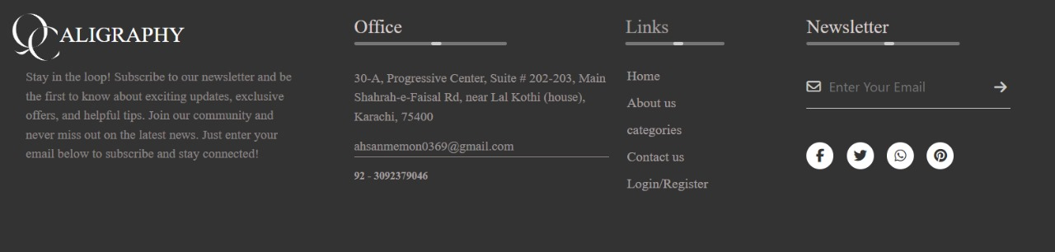

**FOOTER:**

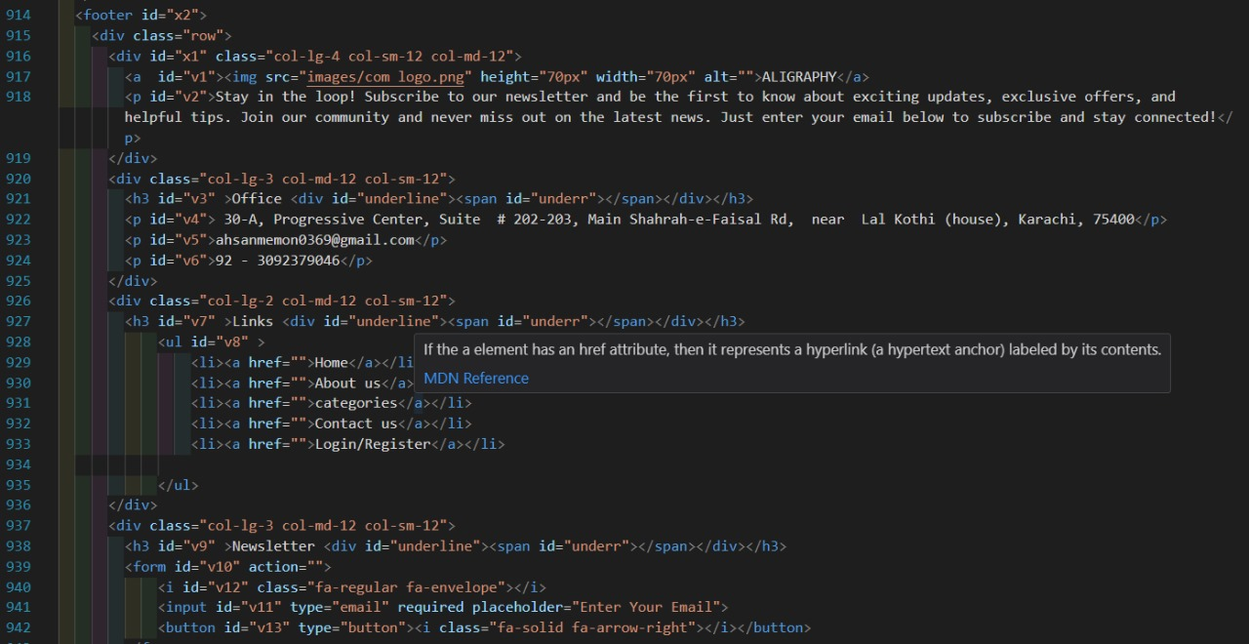

**FOOTER CODE:**

***CATEGORIES*** 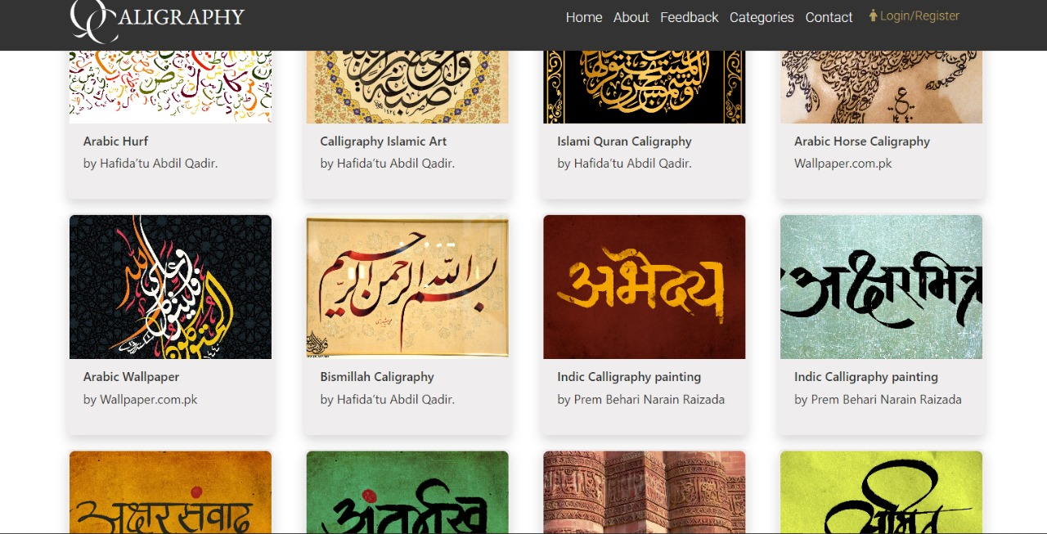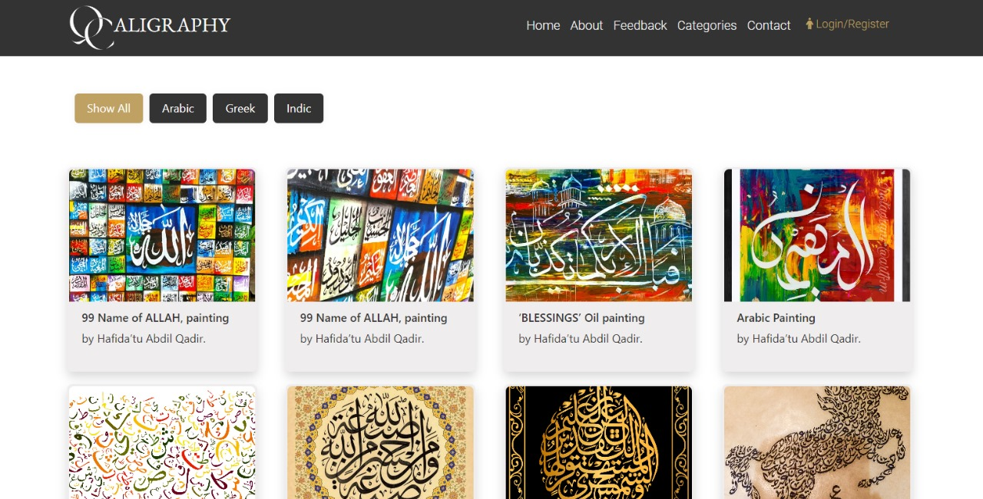

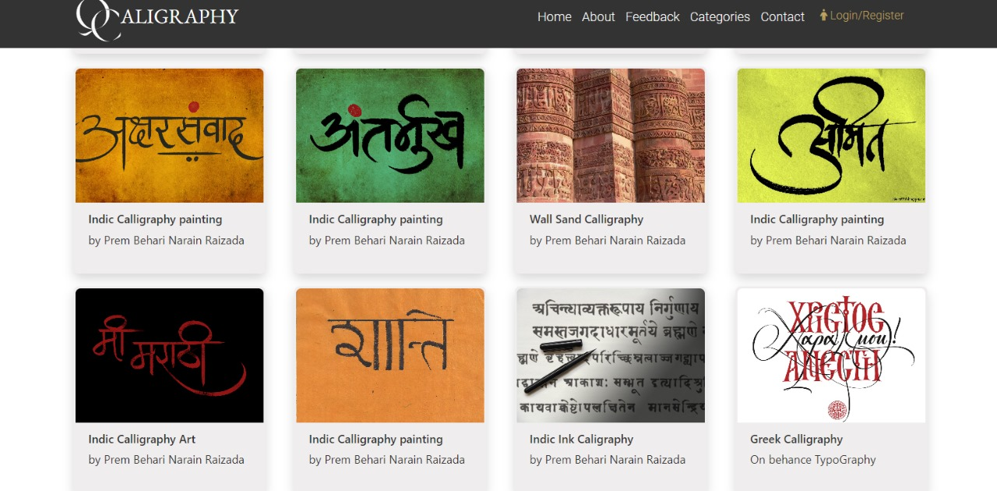 **CATEGORIES CARDS :** 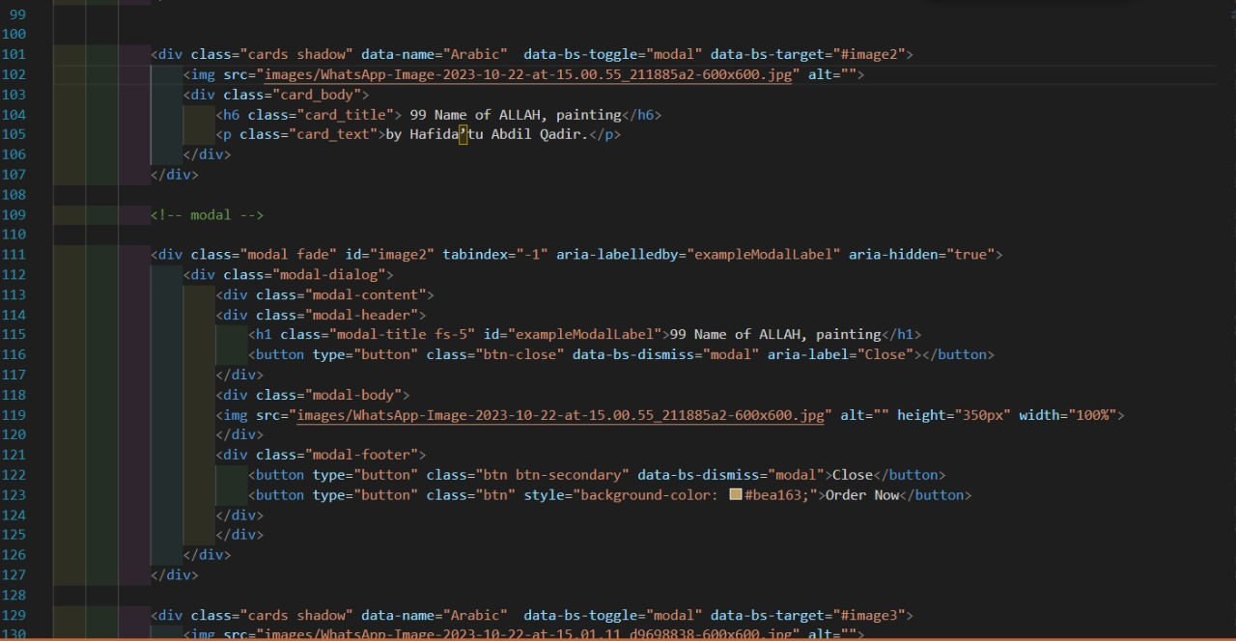

**CATEGORIES CARDS:**

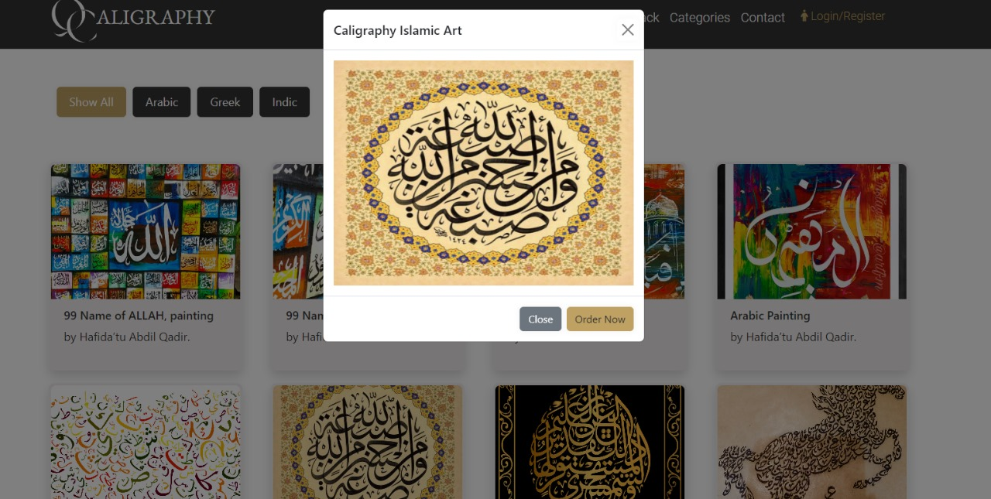

**CATEGORIES CARD MODAL:**

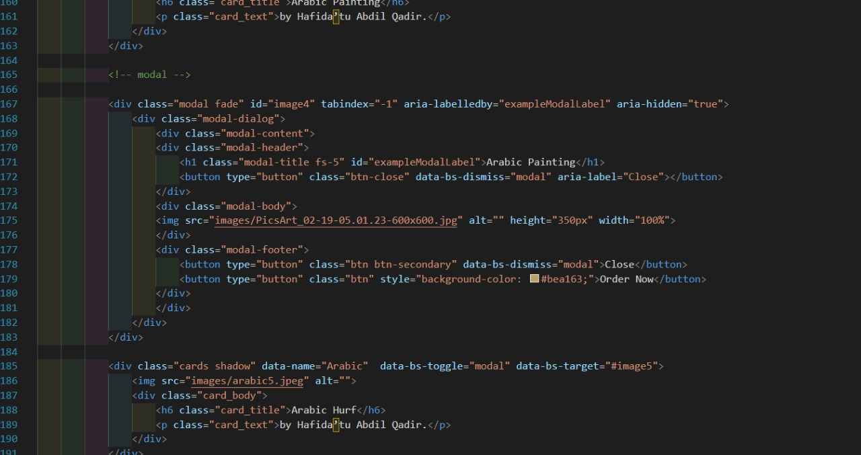

**CATEGORIES CARD MODAL CODE:**

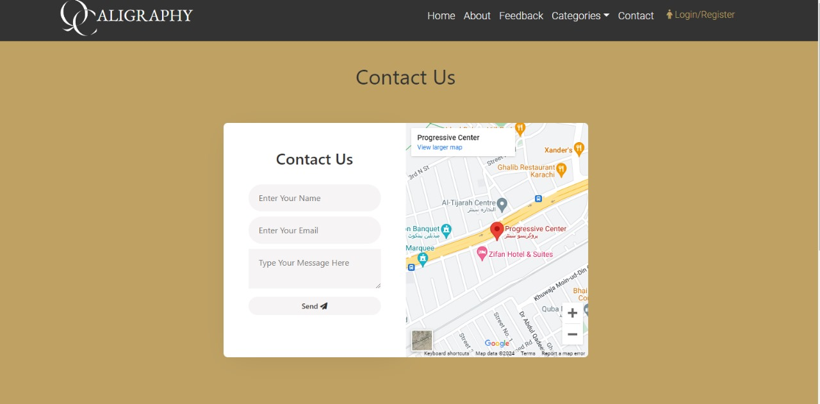**CONTACT US**

**CONTACT US :**

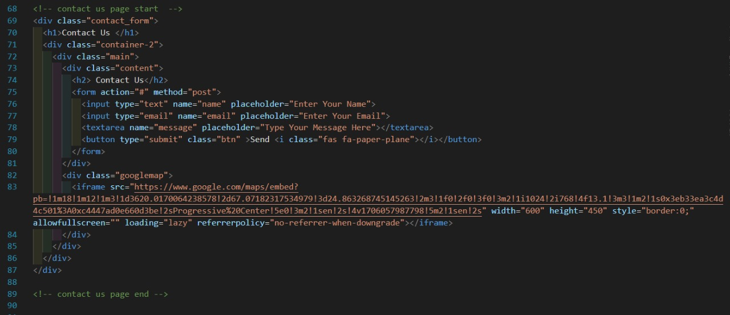

**CONTACT US CODE:**

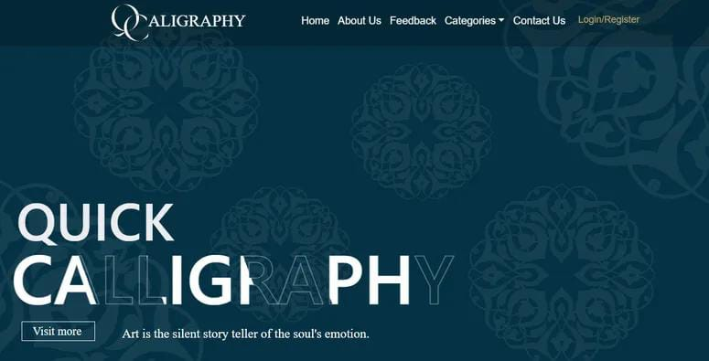***GALLERY***

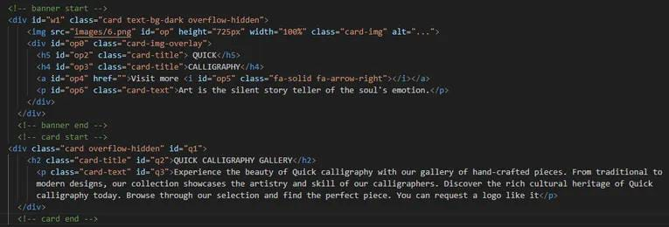**ANIMATE SLIDER:**

**ANIMATE SLIDER HTML CODE:**

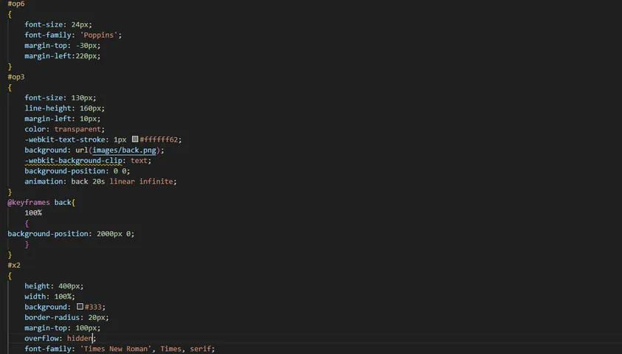

**ANIMATE SLIDER CSS CODE:**

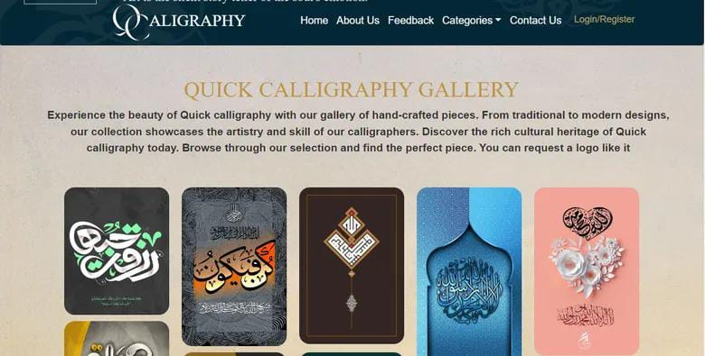

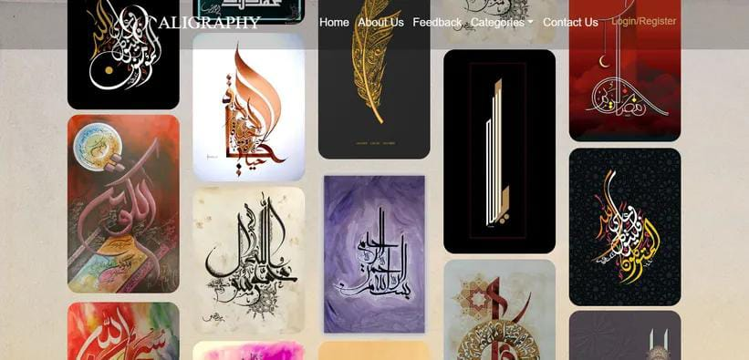

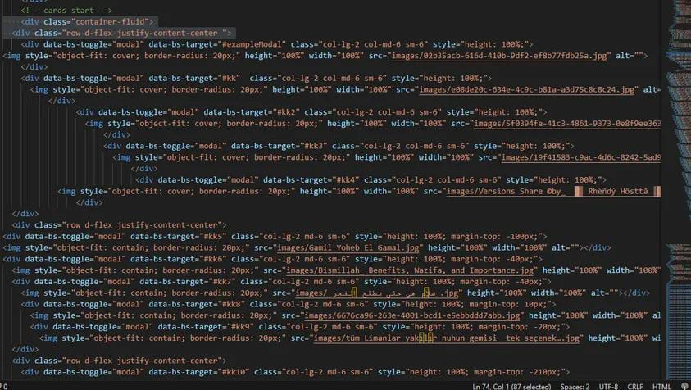**GALLERY CARDS:**

**GALLERY CARDS CODE:**

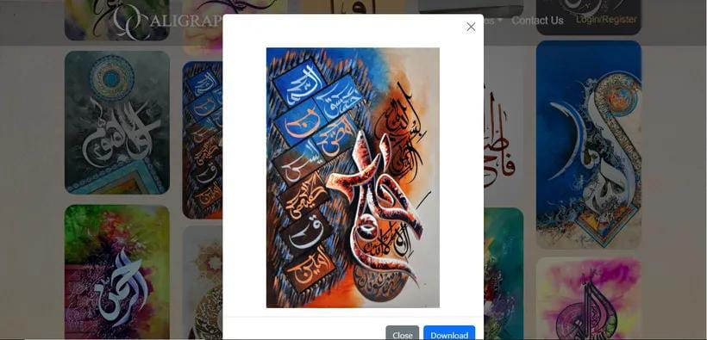

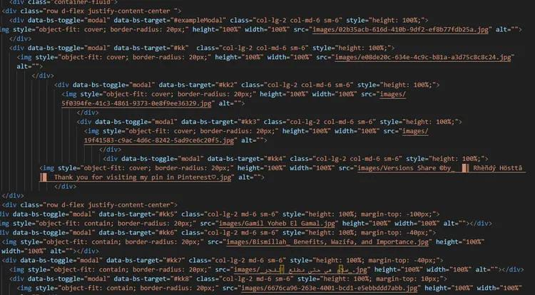**GALLARY MODAL:**

**GALLARY MODAL CODE:**